Experiment No.: 13
Experiment Name: Nmap Timing and Performance
Aim: To study host discovery using Nmap commands in Ubuntu.
Procedure:
- Open the Ubuntu Terminal.
- Check the installed Nmap version using nmap --version.
- Identify the network configuration using ip route.
- Execute nmap -sn 127.0.0.1 to perform host discovery.
- Execute nmap -Pn 127.0.0.1 to skip host discovery and perform a port scan.
- Execute nmap -n -sn 127.0.0.1 to disable DNS resolution during host discovery.
- Observe and record the output.
Screenshots:
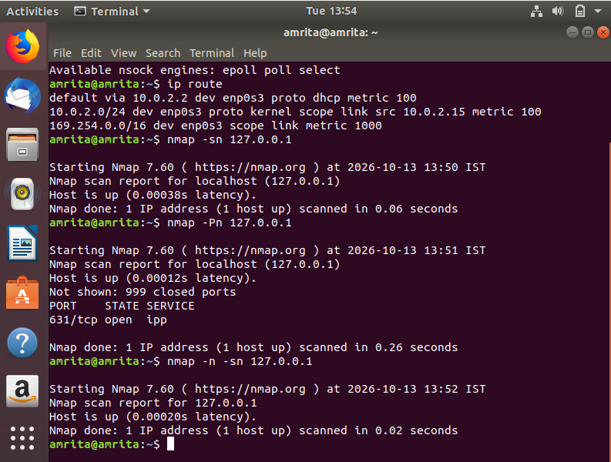
Result: Host discovery was successfully demonstrated using Nmap in Ubuntu, and the functions of the selected Nmap options were studied.

